Alumni Association
List of Members
Name of Member and Designation | Photos
Adv. Rajendra Dange  President  (Secretary, SDSS, Urun-Ishwarpur) | 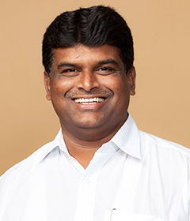
Dr. L.Y. Waghmode  Vice-President  (Director,  ADCET, Ashta) | 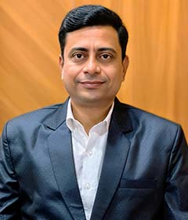
Dr. R. R. Gaji  Secretary  (Dean, Alumni Relations and Strategic Partnership) | 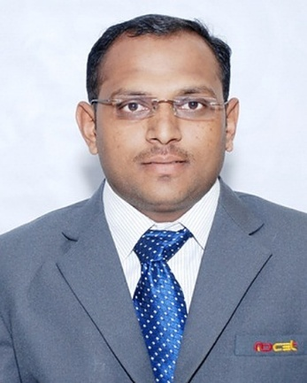
Dr. S. B. Hivarekar  Member  (Dean,  Faculty and Student Development) | 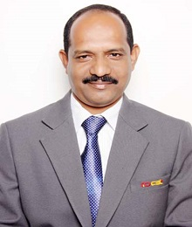
Dr. Gopinath S.  Member  (Dean, Academics) | 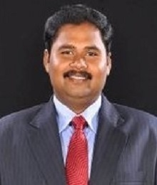
Dr. P. D. Kulkarni  Member  (Dean, International Collaborations) | 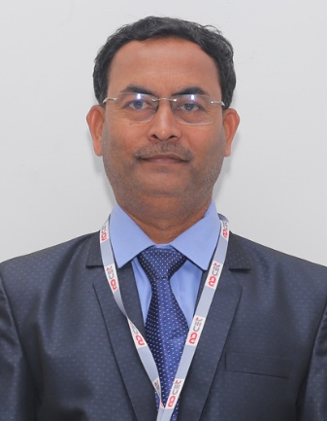
Mr. Sandip Magdum  Member  (Dean, Industry Partnership and Campus Placement) | 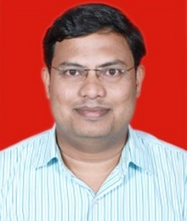
Mr. Vallabh Joshi  Member  (Alumni Representative, Mechanical Engineering) | 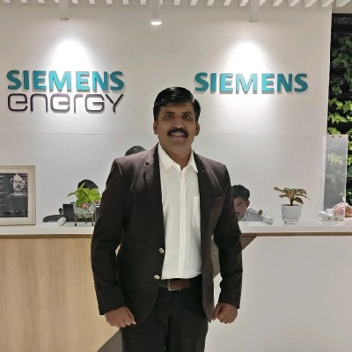
Mr. Sagar Anturkar  Member  (Alumni Representative, Electronics and Telecommunication) | 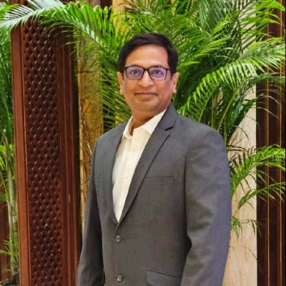
Mr. Vikram Gharge  Member  (Alumni Representative, Information Technology) | 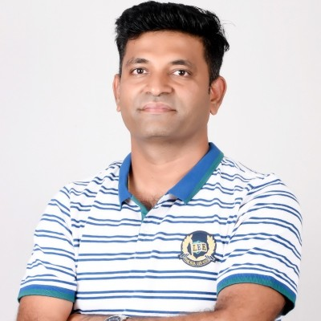
Ms. Anuprit D. Jadhav  Member  (Alumni Representative, Computer Science Engineering) | 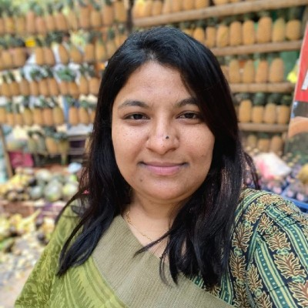
Mr. Vishal Patil
Member

(Alumni Representative, Civil Engineering)

Mr. Amir Khan  Member  (Alumni Representative, Electrical Engineering) | 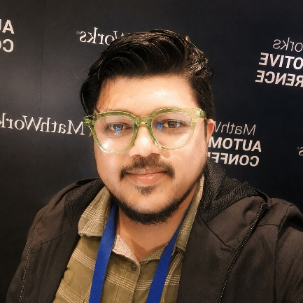
Mr. Ganesh Malgunde  Member  (Alumni Representative, Aeronautical Engineering) | 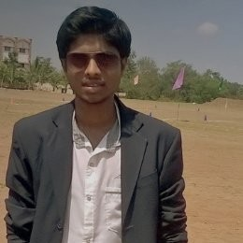
Mr. Prathamesh Dhapate  Member  (Alumni Representative, Food Technology) | 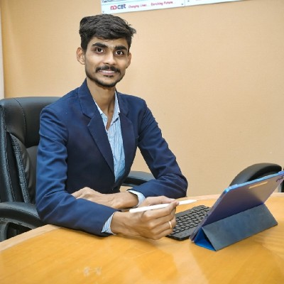
Mrs. A. M. Mulla  Member  (Department Alumni Coordinator, CSE) | 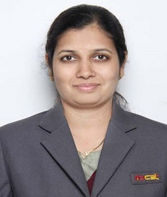
Mr. R. P. Mali  Member  (Department Alumni Coordinator, Mech) | 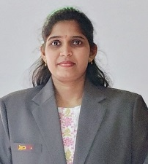
Mr. S. K. Shaikh  Member  (Department Alumni Coordinator, Ele) | 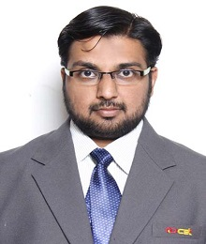
Mr. A. G. Mujawar  Member  (Department Alumni Coordinator, Civil) | 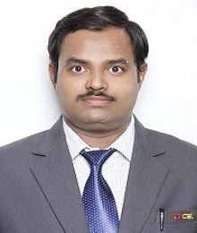
Mr. Y. B. Kumbhar  Member  (Department Alumni Coordinator, Aero) | 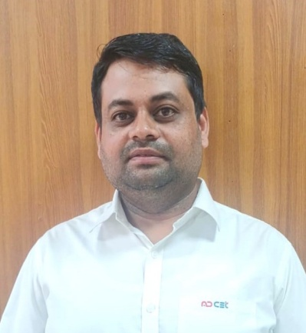
Mr. Ashish Ashok Patil  Member  (Department Alumni Coordinator, Food) | 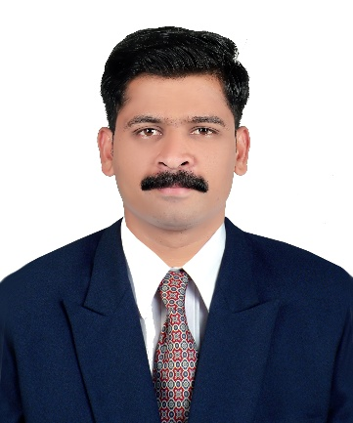
Mrs. S. P. Nalavade  Member  (Department Alumni Coordinator, AIDS) | 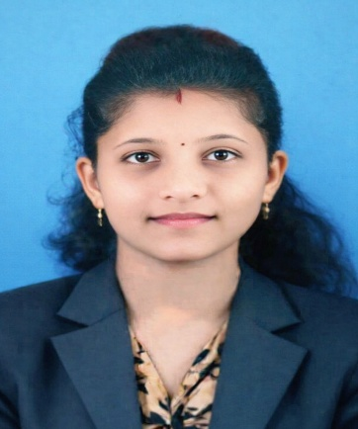
Mrs. P. S. Pathak  Member  (Department Alumni Coordinator, CSE [IoT]) | 